PAPER TITLE

¹presenter author*, ²author
¹company/institution, country, ²company/institution, country

KEYWORDS –
(up to five)

ABSTRACT –
Text (up to 250 words)

TECHNICAL PAPER -

1. PARAGRAPH TITLE

Text….

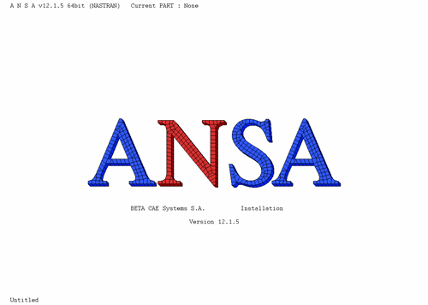

Figure 1 – Text…

Sub-Paragraph Title

Text…

2. PARAGRAPH TITLE

Text….

X. Conclusions

Text….

REFERENCES

- ANSA version 12.1.5 User’s Guide, BETA CAE Systems S.A., July 2008

- μETA PostProcessor version 6.2.0. User’s Guide, BETA CAE Systems S.A., June 2008

