TITLE

¹presenter author*, ²author
¹company/institution, country
²company/institution, country

KEYWORDS –

ABSTRACT –
Text (up to 300 words)

TECHNICAL PAPER -

1. PARAGRAPH TITLE

Text….

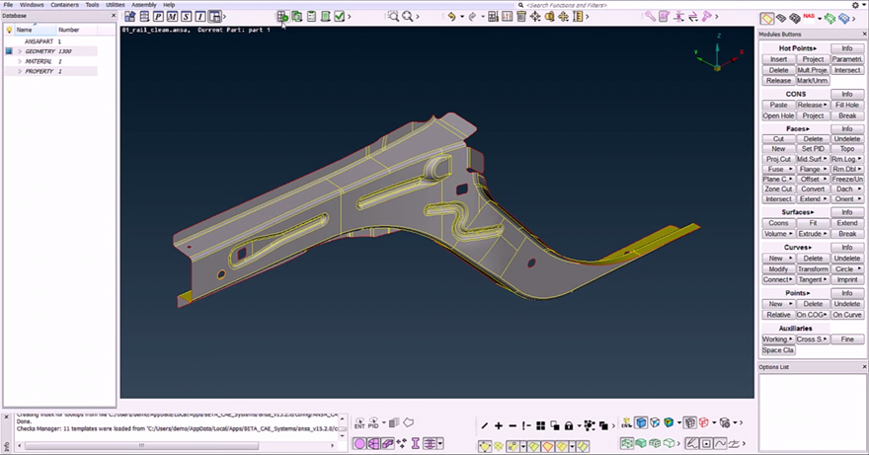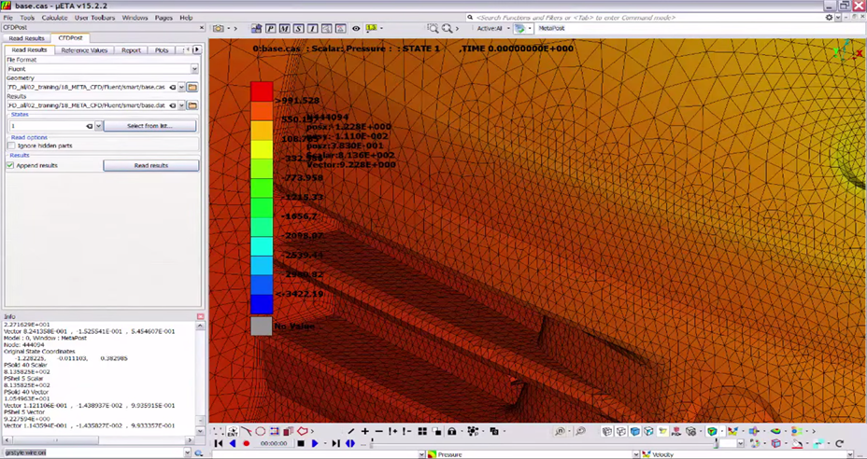
Figure 1 – Text…

Sub-Paragraph Title

Text…

2. PARAGRAPH TITLE

Text….

X. Conclusions

Text….

REFERENCES

- ANSA version 17.0.0 User’s Guide, BETA CAE Systems, July 2015

